**Sequence Diagram:**

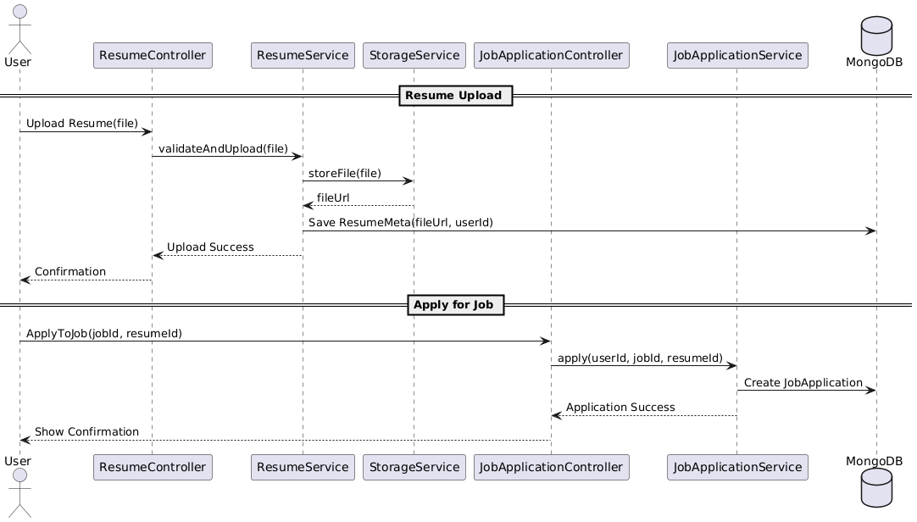

**Class Diagram:**

**State Diagram:**

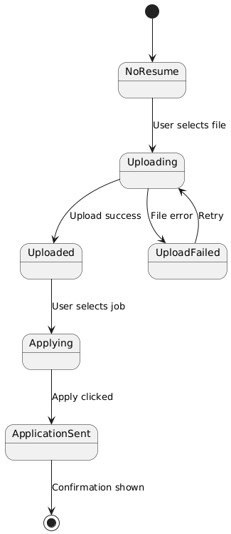

**ERD:**

**Functional Requirements**

1. Users must be able to upload resumes in PDF/DOCX formats.
2. The system must validate the file type and size before uploading.
3. Uploaded resumes should be stored in the user's profile.
4. Users must be able to apply for a job by selecting a resume.
5. The system should record the application and notify the job poster.
6. Users should receive a confirmation of successful application.

**Non-Functional Requirements**

1. Resume files must be stored securely (e.g., cloud storage with access control).
2. Uploads should not exceed 5MB and must complete in under 10 seconds.
3. The application process should be completed in less than 3 seconds.
4. Data consistency and atomicity must be maintained during upload and application.
5. Application logs must be retained securely for auditing.